PRACTICAL NO: 3

Types of Recording

**3A] Basic Recording using Notepad**

1. Launch UiPath Studio and create a new Process project named BasicRecordingNotepad.
2. Open Main.xaml and go to Record → Basic from the top toolbar.
3. In the recorder window, click Open Application and select notepad.exe.

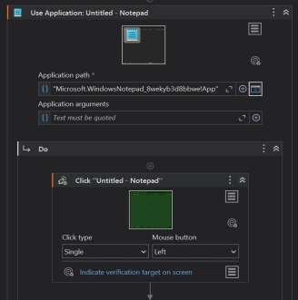

1. Click inside the Notepad window and use Type to enter your message.

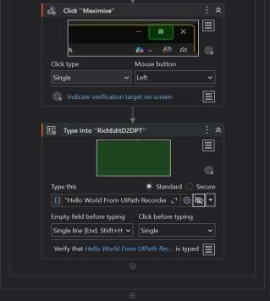

1. Click Save & Exit to add the recorded actions to the workflow.
2. Press Run to see Notepad open and your text typed automatically**.**

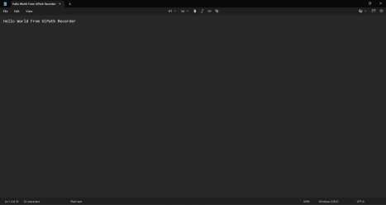

**Conclusion:** Thus we have studied how to create basic Recording using Notepad. 3B] **Basic Recording using G-Mail**

1. Use Recorder to open Gmail in Chrome at https://mail.google.com/mail/u/0/#inbox.
2. Recorder step: Click "Compose" to start a new email.
3. Recorder step: Type [youremail@gmail.com](mailto:youremail@gmail.com) into the To field.
4. Recorder step: Type "Welcome to Email !" in the email body area.
5. Recorder step: Click "Send" to send the email.

